Online Registration in new system
When do I have to save the online registration ?
We have to check is there any “Online Registration” on AAS for AA test & consultation for next day and Click the ‘Online Reg’ at the top.
(Please see Front desk duties and workflow No. 10 for reference)
The below screen will pop up for you to update any new online registration.
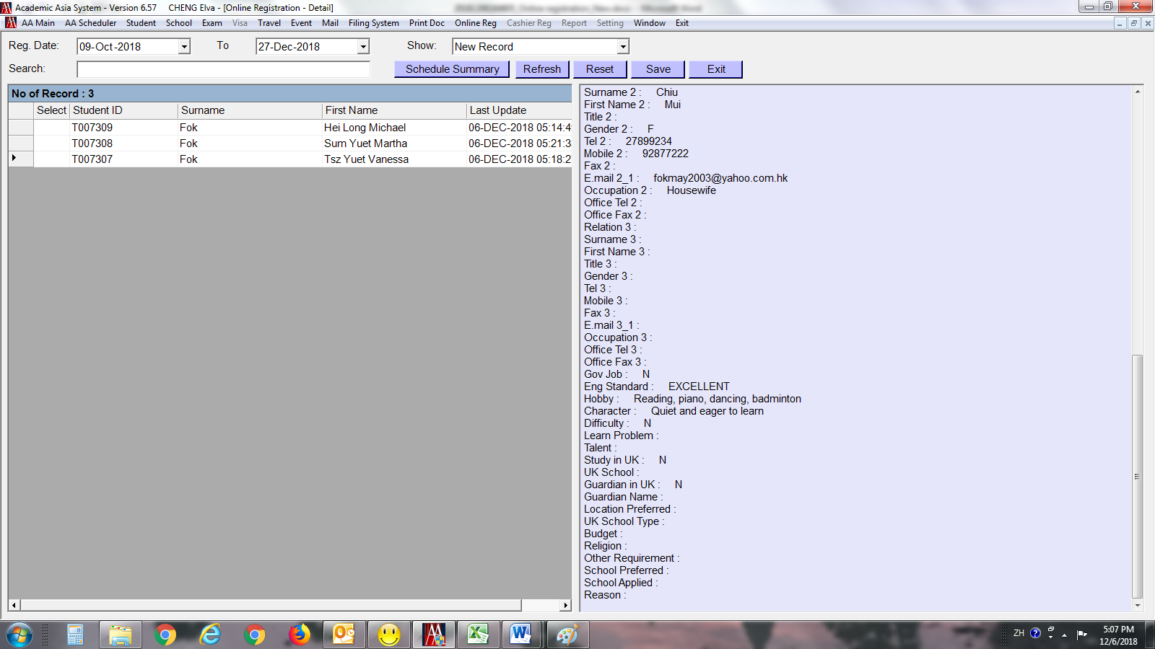

Select the date you want the system to generate, usually do the day before also. For example: if today is 6th Dec, select from 5th Dec to 6th Dec. This allows you to see if any family registered online during the night before. Then press ‘Refresh’.
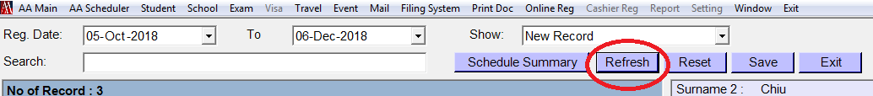
If there are any new online registrations, it will list out as shown below on the left.
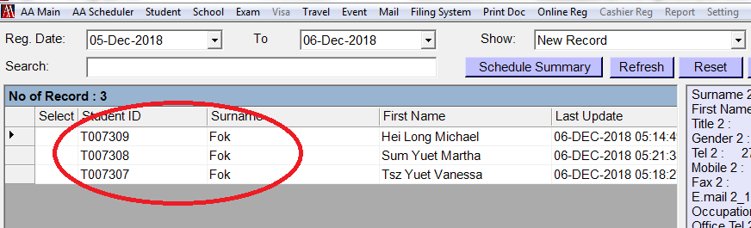

***Important***
Cross check if this student has registered with us before by checking student name and date of birth
If this student never registered with us before, we can then transfer details to the temp file.

To do this, double click the ‘ ’ until ‘1’ appear then press ‘Save’.
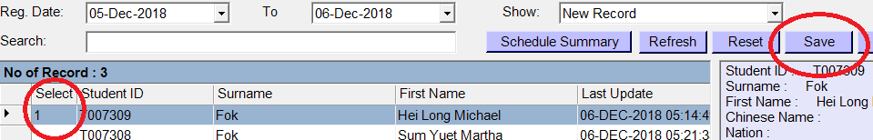

Once you’ve saved the details, all information will be transfer to the student temp file.

To edit the file you’ve just saved/transfer, select today’s date e.g. 6th Dec to 6th Dec (this is the date you saved the file) then select ‘Uploaded Record’ at the ‘SHOW’ drop down (Above refresh button), then press ‘Refresh’.
The list will show the entire file that you’ve been saved/agree to upload.
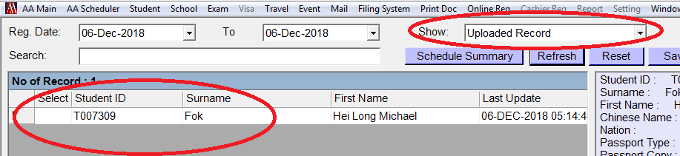

Select the student you want to see the profile, right click, and then select ‘Student Detail’
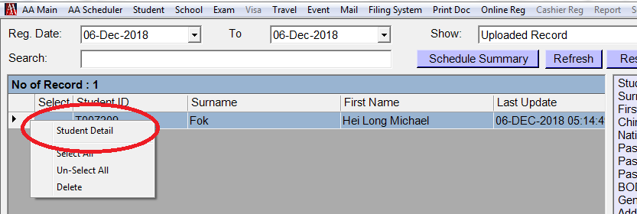

The student file will pop up for you to make any editing such as:
- Change Surname to all Capital letters
- Edit school type
- Edit Source
- Amend student contact details, etc.
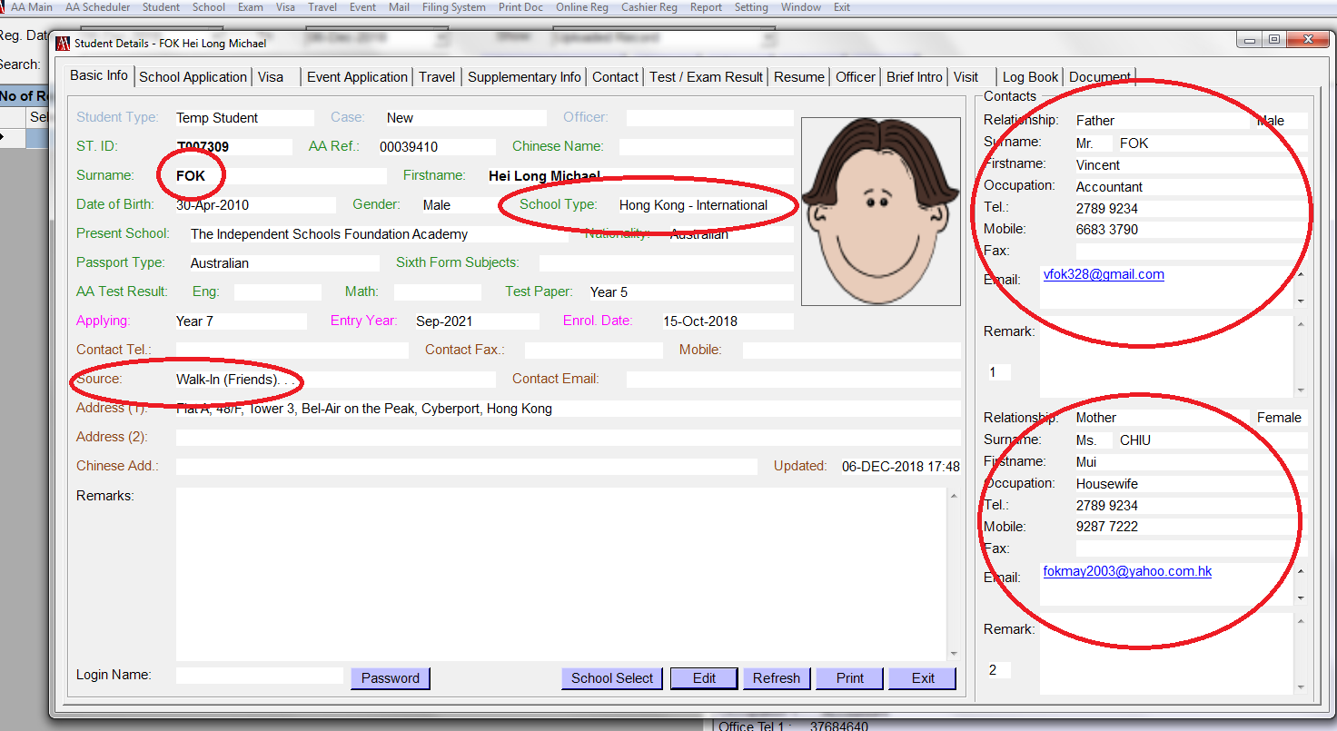

After all the amendment, you can then prepare the orange file. You will not have the SID number i.e. S0032546 until the student arrived on the day of the booking and front desk change the file to AA student.

To check which date the student is coming for the test, select ‘Scheduler Summary’.

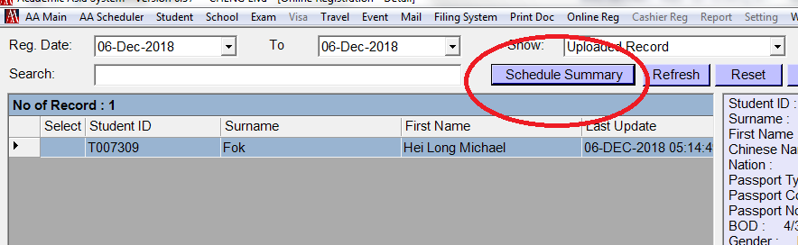

The below box will appear for you to search all the scheduler booking.

Simply search student Surname (DO NOT search the student Full name). It will then let you know which date is the booking, what time is the booking and who it’s being booked under.
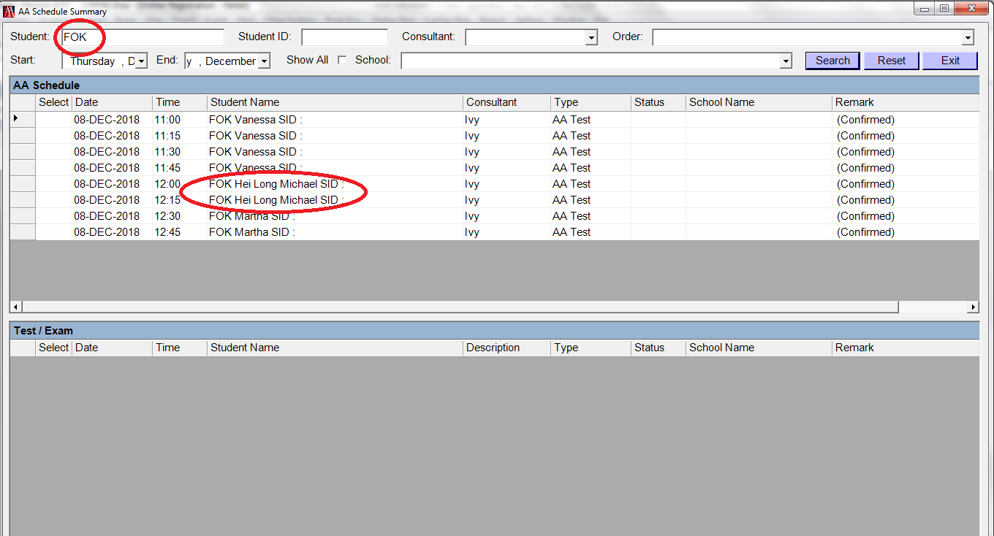

To delete duplicate file
After you cross check and found duplicate file, DO NOT save this new details.
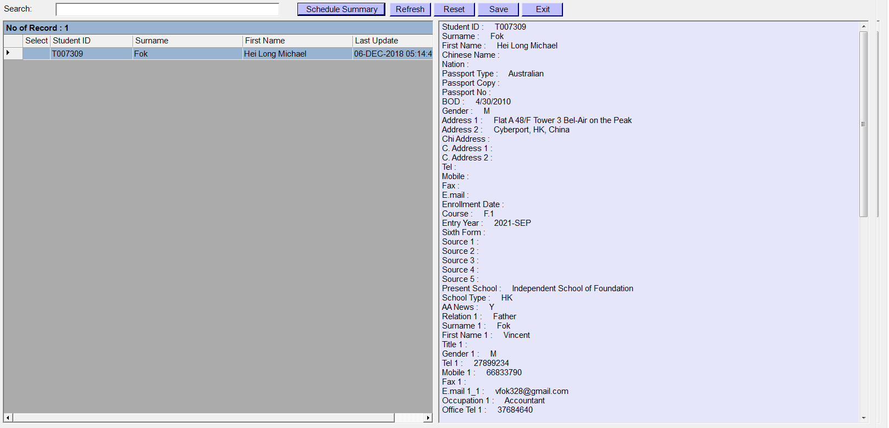
Select the duplicate file, the new information will appear on the right hand side. Double check if there is anything you need to update/copy and paste to the old file such as:
- Address
- Contact details
- Current School
- Apply year group
- Consultant in charged
Once updated, this new file can be deleted.

To do this, double click the ‘ ’ until ‘1’ appear, right click then select ‘Delete’.
